**Verilog HDL**  **DATE : 9/24/2024**

**S A SABBIRUL MOHOSIN NAIM**

**ID; 20176**

**HW: 01**

# 1. Hello World Module

module helloWorld;  
 initial begin  
 $display ("Hello World!!!");  
 #10 $finish;  
 end  
endmodule  
  
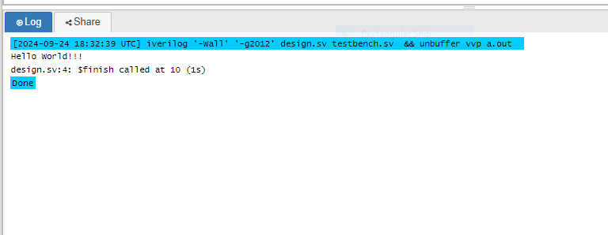

# 2. Digital Circuit Schematic for gates Module

module gates();  
 wire out0;  
 wire out1;  
 wire out2;  
 reg in1, in2, in3, in4;  
 not U1(out0, in1);  
 and U2(out1, in1, in2, in3, in4);  
 xor U3(out2, in1, in2, in3);  
endmodule

Based on the module gates,the digital circuit schematic.  
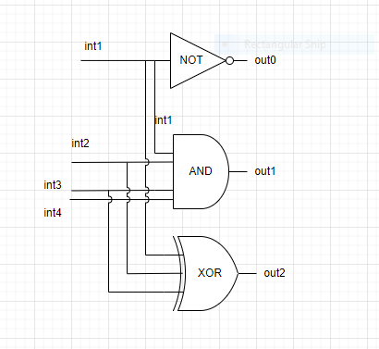

# 3. Testbenches and Simulation for Design Modules

## *oneBitFA1 Module

module oneBitFA1(

input a,

input b,

input ci,

output co,

output sum

);

assign {co, sum} = a + b + ci;

endmodule

module tb_oneBitFA1;

// Inputs

reg a, b, ci;

// Outputs

wire co, sum;

// Instantiate the full adder module

oneBitFA1 uut (

.a(a),

.b(b),

.ci(ci),

.co(co),

.sum(sum)

);

// Initial block to apply inputs

initial begin

// Apply different combinations of inputs

$monitor("At time %0d: a = %b, b = %b, ci = %b, sum = %b, co = %b", $time, a, b, ci, sum, co);

a = 0; b = 0; ci = 0;

#10 a = 0; b = 0; ci = 1;

#10 a = 0; b = 1; ci = 0;

#10 a = 0; b = 1; ci = 1;

#10 a = 1; b = 0; ci = 0;

#10 a = 1; b = 0; ci = 1;

#10 a = 1; b = 1; ci = 0;

#10 a = 1; b = 1; ci = 1;

#10 $finish(); // End the simulation

end

endmodule

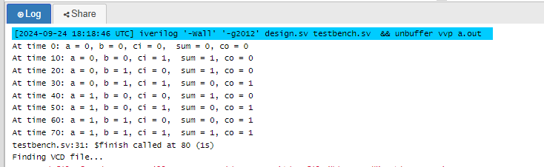

## *oneBitFA2 Module

module oneBitFA2(

input wire a_i,

input wire b_i,

input wire ci_i,

output reg sum_o,

output reg co_o

);

always @(a_i, b_i, ci_i)begin

{co_o, sum_o} = a_i + b_i + ci_i;

end

endmodule

//testbr

module tb_oneBitFA2;

// Inputs

reg a_i;

reg b_i;

reg ci_i;

// Outputs

wire sum_o;

wire co_o;

// Instantiate the design under test (DUT)

oneBitFA2 dut (

.a_i(a_i),

.b_i(b_i),

.ci_i(ci_i),

.sum_o(sum_o),

.co_o(co_o)

);

// Test procedure

initial begin

// Monitor the changes in inputs and outputs

$monitor("a_i=%b, b_i=%b, ci_i=%b -> sum_o=%b, co_o=%b", a_i, b_i, ci_i, sum_o, co_o);

// Apply test cases

a_i = 0; b_i = 0; ci_i = 0; #10; // Test Case 1

a_i = 0; b_i = 0; ci_i = 1; #10; // Test Case 2

a_i = 0; b_i = 1; ci_i = 0; #10; // Test Case 3

a_i = 0; b_i = 1; ci_i = 1; #10; // Test Case 4

a_i = 1; b_i = 0; ci_i = 0; #10; // Test Case 5

a_i = 1; b_i = 0; ci_i = 1; #10; // Test Case 6

a_i = 1; b_i = 1; ci_i = 0; #10; // Test Case 7

a_i = 1; b_i = 1; ci_i = 1; #10; // Test Case 8

// End the simulation

$finish;

end

endmodule

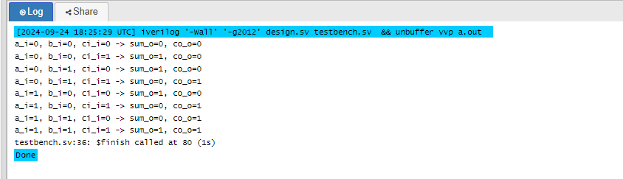

## * DFFSynch Module

module DFFSynch(

d_i,

rst_i,

clk_i,

q_o

);

input d_i,rst_i,clk_i;

output q_o;

reg q_o;

always @(posedge clk_i)begin

if(rst_i) q_o <= 0;

else q_o <= d_i;

end

endmodule

//testbr

module tb_DFFSynch;

// Inputs

reg d_i;

reg rst_i;

reg clk_i;

// Outputs

wire q_o;

// Instantiate the design under test (DUT)

DFFSynch dut (

.d_i(d_i),

.rst_i(rst_i),

.clk_i(clk_i),

.q_o(q_o)

);

// Clock generation

initial begin

clk_i = 0;

forever #5 clk_i = ~clk_i; // 10-unit time period clock

end

// Test procedure

initial begin

// Monitor the changes in inputs and outputs

$monitor("clk_i=%b, rst_i=%b, d_i=%b -> q_o=%b", clk_i, rst_i, d_i, q_o);

// Initialize inputs

rst_i = 1; d_i = 0; #10; // Test Case 1: Reset is active, output should be 0

rst_i = 0; d_i = 1; #10; // Test Case 2: Remove reset, d_i=1, output should follow d_i

d_i = 0; #10; // Test Case 3: d_i=0, output should follow d_i

d_i = 1; #10; // Test Case 4: d_i=1, output should follow d_i

rst_i = 1; #10; // Test Case 5: Activate reset, output should go to 0

// End the simulation

$finish;

end

endmodule

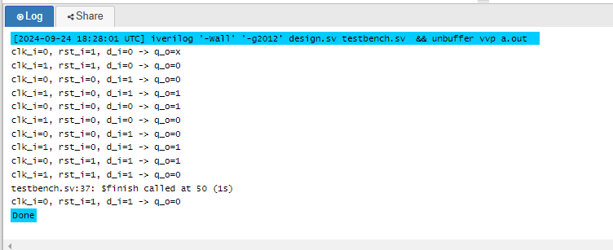

## * DFFAsynch Module

module DFFAsynch(

d_i,

rst_i,

clk_i,

q_o

);

input d_i,rst_i,clk_i;

output q_o;

reg q_o;

always @(posedge clk_i or posedge rst_i)begin

if(rst_i) q_o <= 0;

else q_o <= d_i;

end

endmodule

//tr

module tb_DFFAsynch;

// Inputs

reg d_i;

reg rst_i;

reg clk_i;

// Outputs

wire q_o;

// Instantiate the design under test (DUT)

DFFAsynch dut (

.d_i(d_i),

.rst_i(rst_i),

.clk_i(clk_i),

.q_o(q_o)

);

// Clock generation

initial begin

clk_i = 0;

forever #5 clk_i = ~clk_i; // 10-unit time period clock

end

// Test procedure

initial begin

// Monitor the changes in inputs and outputs

$monitor("clk_i=%b, rst_i=%b, d_i=%b -> q_o=%b", clk_i, rst_i, d_i, q_o);

// Initialize inputs

rst_i = 1; d_i = 0; #10; // Test Case 1: Reset is active, output should be 0

rst_i = 0; d_i = 1; #10; // Test Case 2: Remove reset, d_i=1, output should follow d_i

d_i = 0; #10; // Test Case 3: d_i=0, output should follow d_i

d_i = 1; #10; // Test Case 4: d_i=1, output should follow d_i

rst_i = 1; #10; // Test Case 5: Activate reset, output should go to 0

rst_i = 0; d_i = 1; #10; // Test Case 6: After reset, d_i=1, output should follow d_i

// Add a delay to see the effect of the clock edge

d_i = 0; #10; // Test Case 7: d_i=0, output should follow d_i on next clock edge

#10; // Wait for the clock edge

d_i = 1; #10; // Test Case 8: d_i=1, output should follow d_i on next clock edge

// End the simulation

$finish;

end

endmodule

